Original Research Article
PRODUCTIVITY DYANAMICS OF BLACKGRAM WITH INTERCROPPING OF MINOR MILLETS ON BBF UNDER ORGANIC CULTIVATION
C NAGAHARSHA¹*, A. B. CHOREY², P.V. SHINGRUP³, S. M NEMADE⁴ ,NILIMA K. DAREKAR⁵, V. SRI SHATHA⁶, P. RAJESH⁷, A. NAVYA⁸, Ch. SUPRAJA⁹, GYANASHREE PUSTI¹⁰
Department of Agronomy, Dr. Panjabrao Deshmukh Krishi Vidyapeeth, Akola, Maharashtra, India (MS 444104)
Abstract
Background Information:
Generally low fertility and organic matter content of Indian soils, yield reduction during the conversion to organic farming can be considerable without external inputs. Nevertheless, minor millets, when cultivated with pulses under rainfed conditions, require minimal inputs and can perform relatively well in such systems.
Methodology:
The field experiment was conducted during Kharif season of 2024-25 at certified organic research farm of Centre of Organic Agriculture Research and Training (COART), Department of Agronomy, Dr. Panjabrao Deshmukh Krishi Vidyapeeth, Akola (Maharashtra).
Result :
The application of vermicompost (1 t ha⁻¹) + Jeevamrut (500 L ha⁻¹) + phosphocompost (PROM) (150 kg ha⁻¹) + NPK 10:20:10 kg ha⁻¹; (50% RDF) significantly enhanced the number of seeds pod⁻¹, seed index, seed yield (kg/ha), straw yield (kg/ha) and biological yield (kg/ha), harvest index (%) of blackgram. In foxtail millet, the treatment significantly improved the number of tillers hill⁻¹, number of panicles tiller⁻¹, panicle length, seed yield (kg/ha), straw yield (kg/ha), biological yield (kg/ha) and harvest index (%). Furthermore, this nutrient management practice resulted in higher blackgram equivalent yield and land equivalent ratio, indicating enhanced productivity and resource-use efficiency of the intercropping system.
Keywords: Farming system modules, Blackgram, Foxtail millet, Organic Farming, Natural Farming, Integrated Conventional Farming, Panchagavya Farming, Conventional Farming.
Introduction
Ensuring food and nutritional security, maintaining environmental sustainability, and improving farm profitability for the rapidly growing population remain among the foremost challenges facing modern agriculture (Sharma et al., 2023). At the same time, issues such as environmental degradation, depletion of natural resources, and reduced farm productivity and economic returns have adversely affected the long-term sustainability of agricultural production systems (Babu et al., 2020; Fatima et al., 2023).
Consequently, considerable attention has been directed toward agroecological approaches that enhance crop yields by strengthening ecosystem services. These approaches not only support the achievement of sustainability objectives but also improve agricultural productivity. As nature-based solutions, they have the potential to simultaneously address food insecurity, social inequities, and the interconnected challenges of climate change and biodiversity loss. (Garibaldi et al., 2019 and Seddon et al., 2020).
Natural Farming is an ecological approach to agriculture that relies on naturally occurring processes and resources within and around the farm. It can be described as a system of farming that emphasizes chemical-free cultivation along with livestock-based practices. This approach has the potential to address several emerging challenges, including food insecurity, farmer distress, and health risks associated with pesticide and fertilizer residues in food and water, as well as climate change, global warming, and extreme natural events (Chand and Singh, 2023; Gamit and Vinaya, 2024). Following the Green Revolution, farmers increasingly adopted recommended agricultural technologies to enhance crop productivity. However, the excessive or indiscriminate use of these recommended inputs has, in some instances, resulted in increased production costs and economic losses for farmers (Gamit and Vinaya, 2022).
Among the farmers in India natural Farming has gained widespread adoption in Andhra Pradesh, with most farmers adopting it within the past five years. In contrast, although its adoption began more than 15 years ago in Karnataka and Maharashtra, its spread has remained limited and scattered (Kumar et al., 2023).
Organic farming is an innovative and sustainable agricultural approach that aims to improve crop productivity and enhance farmers’ livelihoods while minimizing environmental impacts (Gamage et al., 2023). It excludes the use of synthetic fertilizers, chemical pesticides, and genetically modified organisms and emphasizes environmentally sustainable farming practices. By reducing dependence on synthetic inputs, organic farming contributes to the production of safe and residue-free food while maintaining soil fertility and supporting ecological balance. However, organic farmers encounter several constraints, including comparatively lower yields, difficulties in maintaining soil fertility, complex certification procedures, and limited market access. Addressing these challenges requires the integration of organic farming practices with appropriate modern technologies and scientific advancements (Hashim et al., 2026).
Integrated Organic farming, which integrates natural farming inputs (NFCs) with conventional organic inputs, has demonstrated promising outcomes in enhancing crop productivity, profitability, and soil health (Kumar et al., 2020). The system integrated with organic and natural inputs shows reduced energy input and greenhouse gas emissions compared to conventional farming (van Der Werf et al., 2020)
Panchagavya farming is an eco-friendly approach for sustainable agriculture and plant disease management. Additional ingredients, including gram flour, jaggery, bananas, and tender coconut water, are sometimes incorporated to enhance microbial activity (Chadha et al., 2012). Panchagavya formulations have been modified to enhance their effectiveness and suit different purposes (Rai et al., 2022).
Several studies have demonstrated that the combined application of organic amendments and inorganic fertilizers can enhance the physical and chemical characteristics of soil, thereby contributing to improved soil fertility (Li et al., 2020; Zhang et al., 2023). Pourmehdi and Kheiralipour (2024) reported that chemical fertilisers are among the major inputs in crop production systems and rank among the second- to third-highest energy-consuming inputs. Fertilizer energy accounted for approximately 41–46% of the total energy consumption in different rainfed cropping systems. Among the fertilizers used in mung bean production, nitrogen, phosphorus, and potassium fertilizers contributed the largest share, accounting for about 33% of the total energy input (Fathi and Kheiralipour, 2025).

Materials and Methods
2.1 Site Description
A field experiment was conducted at certified organic research farm of Centre of Organic Agriculture Research and Training (COART), Department of Agronomy, Dr. PDKV, Akola, Maharashtra (20.6⁰ N latitude and 77.02⁰ E longitude, 307.42 m above mean sea level), India during kharif season 2025. Akola is situated in the subtropical zone.
2.2 Weather
The area receives an average annual rainfall of 811.9 mm based on 30 years of data. Most of the rainfall is received during the month of July to September. The normal mean monthly maximum temperature reaches about 42.6°C in May, which is the hottest month, while the normal minimum temperature drops to 10.3°C in December, the coldest month.
2.3 Soil Characteristics
The soil type in area of study is black cotton soils (Sand- 32.8%, Silt- 21.8%, Clay-45.2%). The initial soil pH- 7.87, EC- 0.29 dSm⁻¹, Organic carbon- 0.46%, medium nitrogen content (212.91 kg/ha), low phosphorus content (13.37 kg/ha), high in potassium content (332.94 kg/ha).
2.4 Treatment and Experimental Details
The experiment was conducted in a completely randomised block design (RBD) with seven treatments and three replications each plot size 6×6 m. Each treatment was arranged randomly within the replication. Every treatment had Blackgram + foxtail millet intercrop (2:1) ratio with different sources of nutrients. Desi varieties of blackgram and foxtail millet “AKU-10-01” and “PDKV Yashshri” were sown with seed rate of 12 kg/ha and 3 kg/ha, respectively. Sowing took place in Kharif season 2025. Treatment details are given in table 1.
2.5 Manures and Fertilizers
Application of Vermicompost @ 5 t ha⁻¹ and FYM @ 2 t ha⁻¹. Recommended dose of fertilizers @ 20:40:20 NPK kg ha⁻¹.
Table 1: Treatment details:
T₁ | Natural Farming | Beejamrutha + Ghanajeevamrutha  (500 kg/ha) +Jeevamrutha @500 l/ha +Mulching
T₂ | Organic Farming | Recommended practices (Vermicompost 2t/ha + Jeevamrutha (500l/ha) + Phosphocompost (PROM) @ (300 kg/ha)
T₃ | Integrated Organic Farming | Beejamrutha + Ghanajeevamrutha  (250 kg/ha) + Vermicompost (1 t/ha) +Phosphocompost (PROM) (150kg/ha) +Jeevamrutha at 15 days interval (500 l/ ha) + Mulching
T₄ | Panchagavya Farming | FYM (2t/ha) + Vermicompost (1 t/ha) + Cow urine @ 10%
T₅ | Integrated Conventional Farming | Vermicompost(1t/ha) + Jeevamrut(500l/ha) +Phosphocompost (PROM) (150kg/ha) + 10:20:10 NPK kg/ha (50% RDF)
T₆ | Conventional Farming | FYM @ 5 t/ha, 20:40:20 NPK kg/ha (GRDF)
T₇ | Absolute Control | No nutrients are applied

* Note:
- Bijamrutha @ 1lit/10 kg seed treatment
- Jeevamrutha @ 500 l/ha in 4 splits as 250 l/ha before sowing, 50 l/ha at 15 DAS, 100 l/ha at 30 DAS and 100 l/ha at 45 DAS
- Cow urine @ 10% at 15,30,45 DAS.
2.6 Calculations
2.6.1 Blackgram Equivalent Yield
Crop equivalent yield was used to compare the productivity of blackgram and foxtail millet under different farming system modules. Blackgram equivalent yield (BEY) was determined by converting the yield of the component crop into the equivalent yield of the main crop. This conversion was based on the yield and prevailing market price of the main crop and its associated intercrop. The MSP of blackgram and foxtail millet during 2025 for each province were considered for calculating the equivalent yields. BEY expressed in t ha⁻¹, were computed using the respective standard formula. (Suhi et al., 2022 and Gitari et al., 2020).

2.6.2 Land Equivalent Ratio
The productivity advantage of intercropping over sole cropping was assessed using the total land equivalent ratio (LER). It was calculated from the yields of the component crops and their respective proportions in the intercropping system using the following equation (Mead and Milley,1980):
LER = Lₐ + L_{b} = (Yᵢₐ / Yₛₐ) + (Yᵢ_{b} / Yₛ_{b})
where Lₐ and L_{b} represent the partial LERs of the main crop (blackgram) and associated crop (foxtail millet), respectively. Yᵢₐ and Yᵢ_{b} denote the yields of the respective crops under intercropping, while Yₛₐ and Yₛ_{b} indicate their yields under sole cropping, expressed in t ha⁻¹. LER represents the relative land area required under sole cropping to produce an equivalent yield obtained from intercropping. An LER value greater than 1 indicates a yield advantage of the intercropping system over monocropping.

Result and discussion
3.1 Plant population
The initial and final plant populations of blackgram and foxtail millet under different treatments are presented in Table 2. Blackgram recorded 126,229 plants ha⁻¹ at emergence and 113,787 plants ha⁻¹ at harvest, while foxtail millet recorded 58,207 and 52,469 plants ha⁻¹, respectively.
3.2 Number of branches per plant
Significantly highest number of branches in blackgram was recorded in integrated conventional farming treatment at 60 DAS (7.73). Among organic nutrient management treatments integrated organic farming treatment recorded higher number of blackgram branches at 60 DAS (7.27) it is at par with organic farming treatment (7.17). Significantly lower number of branches (6.33) were recorded in absolute control treatment, where no nutrients were applied.
3.3 Number of tillers per hill
The maximum number of tillers in foxtail millet was observed under the integrated conventional farming treatment (2.70), at, 60 DAS which remained statistically at par with conventional farming (2.50). Within the organic nutrient management practices, integrated organic farming produced a significantly higher number of tillers (2.23), and this was at par with organic farming (2.17). The absolute control, which received no nutrient inputs, resulted in the least tiller production (1.90). The data related to blackgram number of branches and number of foxtail millet tillers was reported in the table 3. (Murugesan et al., 2025)
The INM treatment (T₅) produced a significantly higher number of tillers per square meter compared to treatments receiving only inorganic fertilizers (T₆). This improvement is likely due to the combined use of slow and fast releasing nutrient sources, which enhanced nutrient availability to the crop, resulting in a greater number of tillers.

3.4 Days to 50% flowering and Days to maturity
The observations regarding the days required for 50 per cent flowering and maturity of blackgram and foxtail millet under various farming system modules are presented in Table 4. Blackgram took an average of 43 days to reach 50% flowering and 78 days for maturity. Foxtail millet showed a similar trend, with an average of 48 days to 50% flowering and 85 days to maturity. The results showed that there was no significant difference in days to maturity and days to 50% flowering on the application of different nutrient sources.
3.5 Yield and Yield parameters
3.5.1 Blackgram
Among the treatments, Integrated Conventional Farming treatment recorded the significantly higher values for all the yield attributes with 6.77 seeds per pod and 20 pods per plant. Among organic nutrient management treatments Organic Farming treatment produced higher number of pods per plant (21.85) compared to other treatments, along with 5.47 seeds per pod. The lowest values among the nutrient management treatments were observed in the Panchagavya Farming treatment, which recorded 4.87 seeds per pod and 18.84 pods per plant. There was no significant difference between treatments for seed index. The data above was presented in table 5 and figure1.
3.5.2 Foxtail millet
Yield attributing characters of foxtail millet were represented in table 6 and figure 2. Integrated Conventional Farming treatment exhibited significantly higher yield attributes, recording 4.30 productive tillers plant⁻¹, 7.47 panicles hill⁻¹, and a panicle length of 11.37 cm. Within the organic nutrient management treatments, Integrated Organic Farming resulted in significantly higher yield attributes, with 4.00 productive tillers plant⁻¹, 6.50 panicles hill⁻¹, and 8.6 cm panicle length. Significantly lower values were recorded in Panchagavya farming treatment among the nutrient management treatments with 3.23 productive tillers plant⁻¹, 5.47 panicles hill⁻¹, and a panicle length of 6.83 cm.
3.6 Seed yield per plant (g)
3.6.1 Blackgram
The maximum seed yield plant⁻¹ was recorded under Integrated Conventional Farming (6.14 g), followed by Conventional Farming (5.36 g). Within the organic nutrient management treatments, the seed yield plant⁻¹ was significantly higher under Integrated Organic Farming (5.10 g), which was statistically at par with Organic Farming (5.07 g).
3.6.2 Foxtail millet
Significantly higher seed yield was obtained with Integrated Conventional Farming, recording 7.40 g plant⁻¹, followed by Conventional Farming with 6.83 g plant⁻¹.Within the organic nutrient management treatments, Integrated Organic Farming recorded significantly higher seed yield plant⁻¹(6.33 g), which was statistically at par with Organic Farming (5.90 g). The data supporting the above information on blackgram and foxtail millet were presented in Table 7.
3.7 Seed yield (kg ha⁻¹)
3.7.1 Blackgram
The seed yield was significantly influenced by the nutrient management treatments, with Integrated Conventional Farming treatment recording the maximum seed yield (774 kg ha⁻¹), followed by Conventional Farming treatment (676 kg ha⁻¹). Among the organic nutrient management treatments, Integrated Organic Farming recorded significantly higher seed yield (644 kg ha⁻¹), which remained statistically at par with Organic Farming (640 kg ha⁻¹). Significantly lower seed yield was recorded in Panchagavya farming treatment with 470 kg ha⁻¹.The lowest seed yield was observed in the absolute control with 319 kg ha⁻¹ . Similar results were seen in research conducted by Singh et al. (2023).
When the organic nutrient management practices were compared, Integrated Organic Farming produced the highest improvement in seed yield, recording a 104% increase over the absolute control. Organic Farming also enhanced seed yield substantially, with a 90.5% increase, while Natural Farming resulted in a 74% increase in yield over the control treatment. In contrast, Panchagavya Farming exhibited the smallest yield advantage, with an increase of 48.8% compared with the absolute control.
3.7.2 Foxtail millet
The highest seed yield was achieved under Integrated Conventional Farming, amounting to 430 kg ha⁻¹, while followed by Conventional Farming with 398 kg ha⁻¹.Considering the organic nutrient management treatments, Integrated Organic Farming recorded the highest seed yield (369 kg ha⁻¹), which was statistically comparable with Organic Farming (343 kg ha⁻¹).The superior yield performance under nutrient-supplied treatments may be attributed to a more consistent supply of essential nutrients, particularly N, P and K, during crop growth, which is in agreement with the observations reported by Shahzadi et al. (2025). The data that represents this information is given in table 7.
The superior yield performance of foxtail millet under intercropping with blackgram may be attributed to biological nitrogen fixation by blackgram, which reduces competition for soil nitrogen. The fixed nitrogen can be transferred to the companion crop through root and nodule decomposition, rhizodeposition and decomposition of crop residues. Similar results were reported by Kumar and Ray (2020).
3.8 Stalk yield (kg ha⁻¹)
3.8.1 Blackgram
The significantly higher stalk yield was obtained under Integrated Conventional Farming treatment, with 710 kg ha⁻¹.Integrated Organic Farming treatment and Organic Farming treatment produced 673 and 633 kg ha⁻¹, respectively.
3.8.2 Foxtail millet
Among the various treatments, significantly highest stalk yield was recorded in Integrated Conventional Farming treatment, ICF with a stalk yield of 723 kg ha⁻¹. This treatment was followed by Conventional Farming treatment, CF, which produced a stalk yield of 692 kg ha⁻¹.
Among organic nutrient management treatments, the Integrated Organic Farming treatment, IOF, recorded significantly higher stalk yield of 645 kg ha⁻¹, followed by Organic Farming treatment, OF with 620 kg ha⁻¹. Table 7 represents this data.
3.9 Biological yield (kg ha⁻¹)
The biological yield of blackgram was significantly influenced by the nutrient management treatments. ICF recorded the highest biological yield (1484 kg ha⁻¹), followed by CF (1373 kg ha⁻¹). Among the organic nutrient management treatments, IOF recorded significantly higher biological yield (1317 kg ha⁻¹), which was statistically at par with OF (1274 kg ha⁻¹). NF, PF and absolute control recorded progressively lower biological yields of 1107, 1014 and 842 kg ha⁻¹, respectively.
Similarly, biological yield of foxtail millet was significantly affected by the nutrient management treatments. The maximum biological yield was recorded under ICF (1154.17 kg ha⁻¹), followed by CF (1091.16 kg ha⁻¹). Among the organic treatments, IOF recorded 1014.52 kg ha⁻¹ and was followed by OF with 963.76 kg ha⁻¹. NF, PF and absolute control recorded lower biological yields of 905.81, 795.52 and 581.01 kg ha⁻¹, respectively.
3.10 Harvest index (%)
Harvest index was significantly influenced by nutrient management treatments in both blackgram and foxtail millet. In blackgram, ICF recorded the highest harvest index (52.57%), followed by CF (49.45%), IOF (48.93%), OF (48.24%), NF (46.49%) and PF (46.37%), while the minimum was recorded under absolute control (37.43%).
A similar trend was observed in foxtail millet, wherein ICF recorded the maximum harvest index (36.80%), followed by CF (36.40%) and IOF (36.34%). OF, NF and PF recorded 35.69, 34.70 and 33.79%, respectively, with the lowest value under absolute control (24.83%). The higher harvest index under ICF may be attributed to better nutrient availability and efficient assimilate partitioning towards reproductive organs, corroborating the findings of Paul et al. (2020).
3.11 Seed to Stalk ratio
In blackgram, the seed-to-stalk ratio was highest under ICF (1.12), followed by CF (0.99), while the lowest value was recorded under absolute control (0.65).
A similar trend was observed in foxtail millet, where ICF recorded the maximum seed-to-stalk ratio (0.59), closely followed by CF (0.58), whereas the minimum ratio was recorded under absolute control (0.47).
3.12 Blackgram Equivalent Yield (kg ha⁻¹)
Crop equivalent yield is considered an effective index for evaluating the overall productivity and production potential of intercropping systems (Reddy et al., 2023). Among the treatments, ICF recorded the highest blackgram equivalent yield (995 kg ha⁻¹), which was statistically at par with CF (881 kg ha⁻¹). Among the organic nutrient management treatments, IOF recorded 833 kg ha⁻¹, followed by OF with 816 kg ha⁻¹. NF registered a blackgram equivalent yield of 702 kg ha⁻¹, whereas the minimum values were observed under PF (608 kg ha⁻¹) and absolute control (411 kg ha⁻¹). The data on blackgram equivalent yield (kg ha⁻¹) are presented in Table 8 and depicted in Fig. 3.
3.13 Land Equivalent Ratio
Land equivalent ratio (LER) is an important index used to assess the efficiency and advantage of intercropping in utilizing available environmental resources compared with sole cropping. An LER value greater than 1 indicates a productivity advantage of intercropping over sole crops, reflecting more efficient utilization of growth resources. Among the different treatments, the highest Land Equivalent Ratio (LER) was recorded in the Integrated Conventional Farming (ICF) treatment with a value of 1.43, followed by Conventional Farming (CF) treatment with 1.33. The Integrated Organic Farming (IOF) treatment recorded an LER of 1.32, while Organic Farming (OF) treatment registered 1.26. Natural Farming (NF) treatment recorded an LER of 1.18. The lowest LER was observed in Panchagavya Farming (PF) treatment with 1.10 and Absolute Control with 1.00. The higher LER under ICF treatment may be attributed to better complementarity between the component crops, resulting in efficient utilization of available growth resources. Similar findings were reported by Muralidhar M. S. (2020)
The data was presented in table 8 and figure 4.

Conclusion
Application of Vermicompost (1t/ha) + Jeevamrut (500lit/ha) + Phosphocompost (PROM) (150 kg) + 10:20:10 NPK kg/ha (50% RDF) significantly enhanced number of pods per plant, seeds per pod and seed yield and straw yield of blackgram. In foxtail millet number of tillers per hill, number of panicles per hill, panicle length (cm), test weight (g), grain and straw yield. It also improved blackgram and foxtail millet yield, blackgram equivalent yield, Land equivalent ratio followed by T₆ treatment by the application of FYM @ 5 t/ha + 20:40:20 NPK kg/ha (GRDF).
Acknowledgement
The authors sincerely thank the reviewers for their valuable comments, constructive suggestions, and critical evaluation, which greatly contributed to improving the quality, clarity, and scientific presentation of this manuscript. The authors also express their gratitude to all those who provided support and assistance during the course of this research.
.
Referances:

Babu, S., Mohapatra, K. P., Das, A., Yadav, G. S., Tahasildar, M. and Singh, R., 2020. Designing energy-efficient, economically sustainable, and environmentally safe cropping system for the rainfed maize–fallow land of the eastern Himalayas. Science of the Total Environment, 722, 137874.
Chand, R. and Singh J., 2023. From Green Revolution to Amrit Kaal Lessons and Way Forward for Indian Agriculture. Working Paper 02/2023. National Institution for Transforming India, Government of India, New Delhi. 44 p.
Fathi, A. and Kheiralipour, K., 2025. Investigating the energy consumption and carbon footprint in mung bean production ecosystems in Iran. Biosystems Engineering and Renewable Energies, 1(1), 59-63.
Fatima, A., Singh, V. K., Babu, S., Singh, R. K., Upadhyay, P. K., Rathore, S. S., Kumar, B., Hasanain, M. and Parween, H., 2023. Food production potential and environmental sustainability of different integrated farming system models in northwest India. Frontiers in Sustainable Food Systems, 7, 959464.
Gamage A, Gangahagedara R, Gamage J, Jayasinghe N, Kodikara N, Suraweera P, Merah O., 2023. Role of organic farming for achieving sustainability in agriculture. Farming System 100005.
Gamit, Rohan A. and Vinaya Kumar H. M., 2024. Perception of farmers about natural farming. Gujarat Journal of Extension Education, 38(2):195-200.
Gamit, Rohan A. and Vinaya Kumar, H. M., 2022. Farmers attitude towards zero budget natural farming. Gujarat Journal of Extension Education, 34(2): 41-46.
Garibaldi, L. A., Perez-Mendez, N., Garratt, M. P., Gemmill-Herren, B., Miguez, F. E. and Dicks, L. V., 2019. Policies for ecological intensification of crop production. Trends in ecology & evolution, 34(4), 282-286.
Gitari, H.I., Nyawade, S.O., Kamau, S., Karanja, N.N., Gachene, C.K., Raza, M.A., Maitra, S. and Schulte-Geldermann, E., 2020.Revisiting intercropping indices with respect to potato-legume intercropping systems. Field Crops Research, 258, 107957.
Hashim, M., Kumar, N., Hazra, K. K., Nath, C. P., Kumar, A., Dinkar, V., and Deo, M. M., 2026. Organic farming involving pulse crops and its systems for ecological sustainability. Journal of Food Legumes, 39 (Special issue), 106-114.
Kumar, B. and Ray, P., 2020. Performance of intercropping of legumes with finger millet (Eleusine coracana) for enhancing productivity, sustainability and economics in Koshi region of Bihar. Journal of Pharmacognosy and Phytochemistry; 9(3): 1568-1571.
Kumar, R., Kumar, S., Yashavanth, B. S., Venu, N., Meena, P. C., Dhandapani, A. and Kumar, A., 2023. Natural farming practices for chemical-free agriculture: implications for crop yield and profitability. Agriculture, 13(3), 647.
Kumar, S., Meena, R.S., Datta, R., Verma, S.K., Yadav, G.S., Pradhan, G., Molaei, A., Rahman, G.K.M. and Mashuk, H.A., 2020. Legumes for carbon and nitrogen cycling: an organic approach. In: Meena RS, Das A, Yadav GS, Lal R Carbon and Nitrogen Cycling in Soil. Springer, Singapore, pp 337–375.
Li P, Wu M C, Kang G D, Zhu B J, Li H X, Hu F and Jiao J G., 2020. Soil quality response to organic amendments on dryland red soil in subtropical China. Geoderma, 373, 114416.
MURLIDHAR, M. S., 2020. ASSESSMENT OF PRODUCTIVITY OF INTERCROPPING OF MINOR MILLETS WITH BLACKGRAM ON BBF UNDER ORGANIC CULTIVATION (Doctoral dissertation, DR. PANJABRAO DESHMUKH KRISHI VIDYAPEETH).
Murugesan, S. K., Narashimamoorthy, T., Sivalingam, R., Arumugam, R., Manivelu, R. and Padmanaban, B., 2025. Influence of nutrient management practices on growth and yield performance of foxtail millet (Setaria italica L.) in irrigated conditions. Agric. Sci. Digest.
Paul, M.J., Watson, A. and Griffiths, C.A., 2020. Linking fundamental science to crop improvement through understanding source and sink traits and their integration for yield enhancement. Journal of Experimental Botany. 71(7): 2270-2280.
Pourmehdi, K. and Kheiralipour, K., 2024. Net energy gain efficiency, a new indicator to analyze energy systems, case study: Comparing wheat production systems. Results in Engineering, 22, 102211.
Rai, S., Rao, P. S., Sharma, V., Pradhan, D. and Singh, R., 2022. Antimicrobial potential of panchagavya formulation from Indian cow breeds. International Journal of Bioresources and Stress Management, 13(6), 613-621.
Reddy, R.D., Pillai, P.S., John, J., Sajeena, J. and Aswathy, J.C., 2023. Growth and yield of pulses influenced by intercropping with finger millet [Eleusine coracana (L.) Gaertn.] in South Laterites of Kerala. Legume Research. 46: 1211-1215.
Reganold, J.P. and Wachter, J.M., 2016. Organic agriculture in the twenty-first century. Nature Plants. 2(2): 1-8.
Seddon, N., Chausson, A., Berry, P., Girardin, C. A., Smith, A. and Turner, B., 2020. Understanding the value and limits of nature-based solutions to climate change and other global challenges. Philosophical Transactions of the Royal Society B: Biological Sciences, 375(1794), 20190120.
Shahzadi, H., Khan, S., Al-Hashimi, A., Basra, S.M., Mehmood, K., Wahid, M.A., Nawaz, M., Irshad, S., Haseeb, A., Rais, A. and Gul, S., 2025. Preliminary study on unlocking growth and yield potential of USDA foxtail millet (Setaria italica L.) lines with NPK fertilization. BMC Plant Biology. 25(1): 22.
Sharma, K., Walia, S. S., Dhaliwal, S. S., Saini, K. S. and Bhagat, R., 2023. Residual effect of nitrogen management on succeeding summer moong (Vigna radiata) under maize-wheat- moong rotation. Indian Journal of Agricultural Sciences, 93, 762–777.
Singh, A., Lal, M., Shivashankar, K., Singh, K. S. and Tiwari, R., 2023. Effect of natural farming practices on growth and yield of black gram under pigeonpea+ black gram cropping system. The Pharma Innovation Journal, 12(3), 5871-5874.
Suhi, A.A., Mia, S., Khanam, S., Mithu, M.H., Uddin, K., Muktadir, A., Ahmed, S., Jindo, K., 2022. How Does Maize-Cowpea Intercropping Maximize Land Use and Economic Return? A Field Trial in Bangladesh Land, 11, 581.
Van Der Werf, H. M., Knudsen, M. T. and Cederberg, C., 2020. Towards better representation of organic agriculture in life cycle assessment. Nature Sustainability, 3(6), 419–425.
Zhang J L, Nie J, Cao W D, Gao Y J, Lu Y H and Liao Y L., 2023. Long-term green manuring to substitute partial chemical fertilizer simultaneously improving crop productivity and soil quality in a double-rice cropping system. European Journal of Agronomy, 142, 126641.

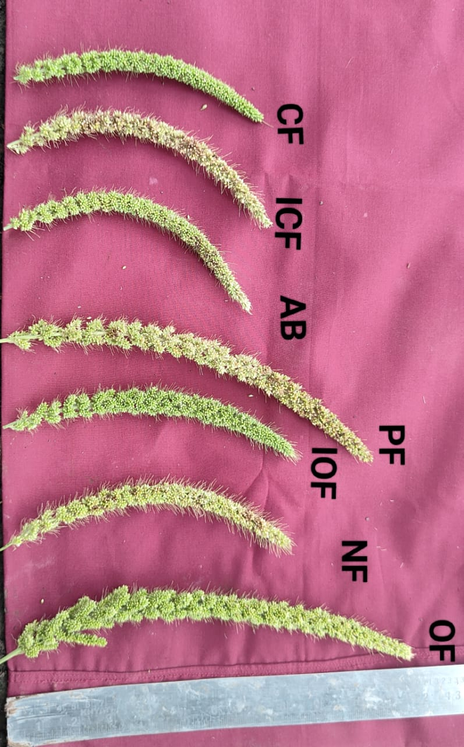
Plate 1: Panicle length of foxtail millet intercropped with blackgram influenced by different farming system modules
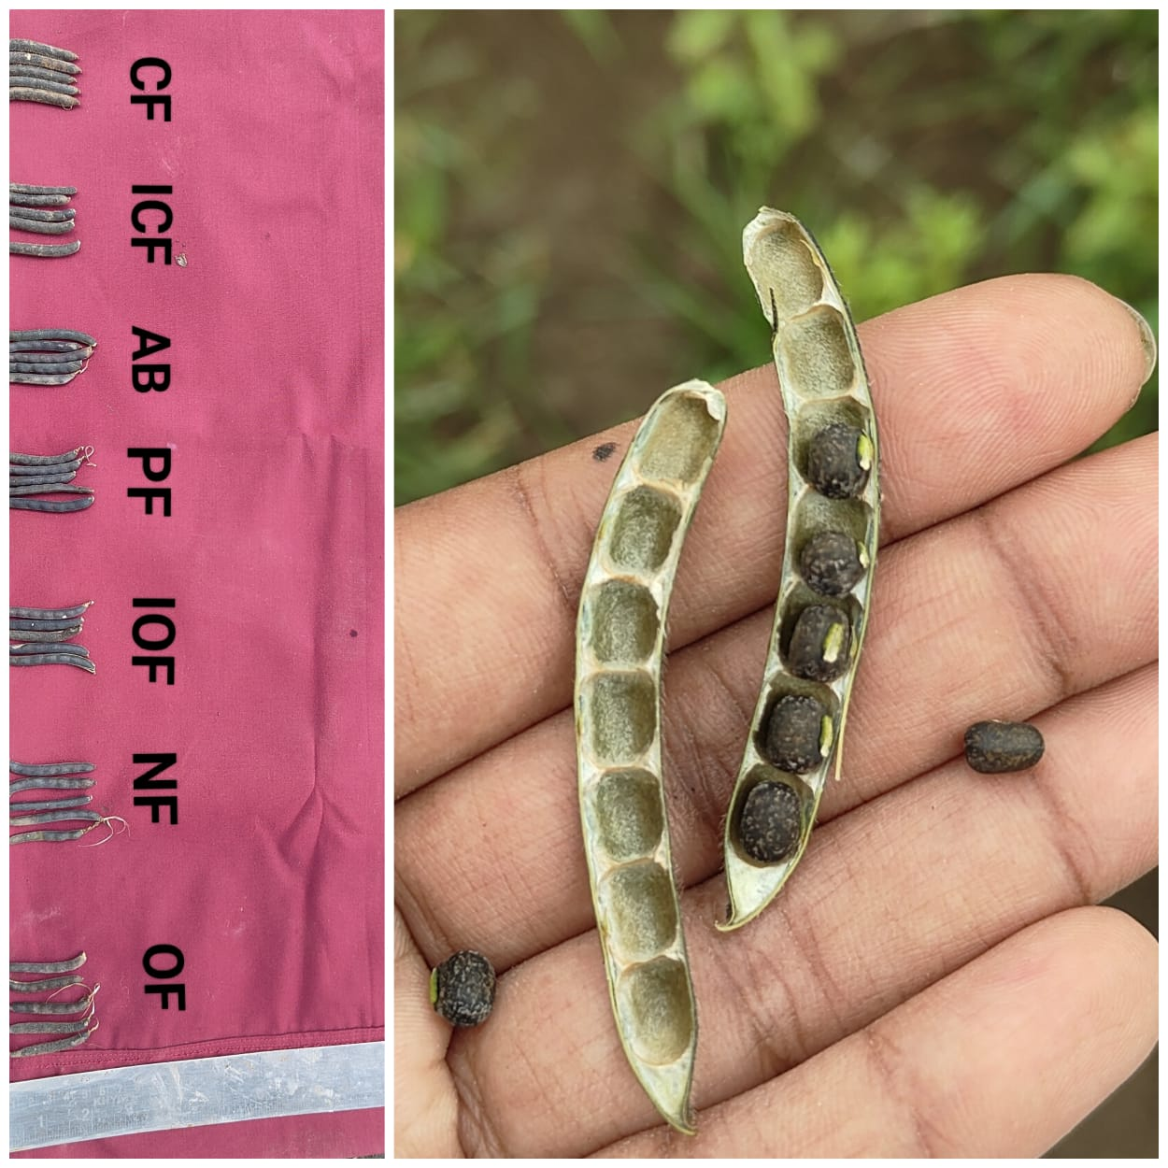
Plate 2: Pod length and number of seeds per pod of blackgram in blackgram + foxtail millet intercropping system as influenced by different farming system modules
Table 2: Plant population (ha⁻¹) of blackgram and foxtail millet as influenced by different farming system modules.

Treatments | Blackgram plant stand |  | Foxtail millet plant stand
 | Initial count (plants ha⁻¹) | Final count (plants ha⁻¹) | Initial count (plants ha⁻¹) | Final count (plants ha⁻¹)
T₁- NF | 126246 | 113621 | 58197 | 52377
T₂- OF | 126243 | 114881 | 58192 | 52955
T₃- IOF | 126242 | 116143 | 58212 | 53555
T₄- PF | 126193 | 112312 | 58191 | 51790
T₅- ICF | 126245 | 111096 | 58239 | 51250
T₆- CF | 126244 | 118669 | 58230 | 54736
T₇- AB | 126189 | 109784 | 58186 | 50622
SE(m) ± | 4810 | 4553 | 2176 | 2024
CD at 5% | NS | NS | NS | NS
GM | 126229 | 113787 | 58207 | 52469

Table 3: Number of branches plant⁻¹ of blackgram and number of tillers hill ⁻¹ of foxtail millet as influenced by different treatments
Treatments | Number of branches plant⁻¹ |  |  | Number of tillers hill ⁻¹
 | Blackgram |  |  | Foxtail millet
 | 20 DAS | 40 DAS | 60 DAS | 20 DAS | 40 DAS | 60 DAS
T1- NF | 2.73 | 2.92 | 7.10 | 1.27 | 1.97 | 1.97
T2- OF | 2.80 | 2.93 | 7.17 | 1.47 | 2.05 | 2.17
T3- IOF | 2.83 | 3.00 | 7.27 | 1.50 | 2.17 | 2.23
T4- PF | 2.70 | 2.87 | 6.73 | 1.10 | 1.92 | 2.00
T5- ICF | 3.20 | 3.57 | 7.73 | 1.80 | 2.63 | 2.70
T6- CF | 2.87 | 3.13 | 7.50 | 1.70 | 2.27 | 2.50
T7- AB | 2.67 | 2.77 | 6.33 | 1.00 | 1.20 | 1.90
SE(m) ± | 0.16 | 0.13 | 0.25 | 0.09 | 0.25 | 0.12
CD at 5% | NS | 0.40 | 0.76 | NS | 0.75 | 0.37
GM | 2.83 | 3.03 | 7.12 | 1.40 | 2.03 | 2.21

Table 4: Days to 50% flowering and Days to maturity of Blackgram and Foxtail millet as influenced by different farming system modules.
Treatments | Days to 50% flowering |  | Days to maturity
 | Blackgram | Foxtail millet | Blackgram | Foxtail millet
T₁- NF | 42 | 46 | 76 | 84
T₂- OF | 43 | 47 | 77 | 86
T₃- IOF | 44 | 49 | 79 | 87
T₄- PF | 41 | 45 | 75 | 83
T₅- ICF | 46 | 52 | 82 | 89
T₆- CF | 45 | 51 | 81 | 88
T₇- AB | 40 | 44 | 73 | 81
SE(m) ± | 3 | 2 | 3 | 4
CD at 5% | NS | NS | NS | NS
GM | 43 | 48 | 78 | 85

Table 5: Number of pods plant⁻¹, number of seeds pod⁻¹ and seed index (g) of blackgram as influenced by different farming system modules.

Treatments | Number of pods plant⁻¹ | Number of seeds pod ⁻¹ | seed index (g)
T₁- NF | 19.85 | 5.27 | 4.10
T₂- OF | 21.85 | 5.47 | 4.27
T₃- IOF | 20.47 | 5.77 | 4.30
T₄- PF | 18.84 | 4.87 | 4.07
T₅- ICF | 20.00 | 6.77 | 4.53
T₆- CF | 18.70 | 6.37 | 4.50
T₇- AB | 15.35 | 4.80 | 4.00
SE(m) ± | 0.85 | 0.35 | 0.33
CD at 5% | 2.60 | 1.06 | NS
GM | 19.29 | 5.61 | 4.25

Table 6: Number of productive tillers hill⁻¹, number of panicles hill⁻¹ and panicle length (cm) of foxtail millet as influenced by different farming system modules.
Treatments | Number of productive tillers hill⁻¹ | Number of panicles hill⁻¹ | Panicle length (cm)
T₁- NF | 3.60 | 5.77 | 6.90
T₂- OF | 3.87 | 6.00 | 8.17
T₃- IOF | 4.00 | 6.50 | 8.60
T₄- PF | 3.23 | 5.47 | 6.83
T₅- ICF | 4.30 | 7.47 | 11.37
T₆- CF | 4.10 | 7.27 | 8.87
T₇- AB | 2.87 | 5.00 | 6.10
SE(m) ± | 0.13 | 0.10 | 0.40
CD at 5% | 0.41 | 0.32 | 1.24
GM | 3.71 | 6.21 | 8.12

Table 7: Seed yield plant ⁻¹ (g), seed yield (kg ha⁻¹), stalk yield (kg ha⁻¹), biological yield (kg ha⁻¹), harvest index (%) and seed to stalk ratio of Blackgram and Foxtail millet as influenced by different farming system modules.
Treatments | Seed yield plant ⁻¹ (g) |  | Seed yield (kg ha⁻¹) |  | Stalk yield (kg ha⁻¹) |  | Biological yield (kg ha⁻¹) |  | Harvest index (%) |  | Seed to stalk ratio
 | BG | FM | BG | FM | BG | FM | BG | FM | BG | FM | BG | FM
T₁- NF | 4.29 | 5.40 | 541 | 314 | 566 | 591 | 1107 | 905 | 46.49 | 34.70 | 0.98 | 0.53
T₂- OF | 5.07 | 5.90 | 640 | 343 | 633 | 620 | 1274 | 963 | 48.24 | 35.69 | 1.05 | 0.58
T₃- IOF | 5.10 | 6.33 | 644 | 368 | 673 | 645 | 1317 | 1014 | 48.93 | 36.34 | 0.98 | 0.57
T₄- PF | 3.73 | 4.60 | 470 | 268 | 543 | 526 | 1014 | 795 | 46.37 | 33.79 | 0.98 | 0.48
T₅- ICF | 6.14 | 7.40 | 774 | 430 | 710 | 723 | 1484 | 1154 | 52.57 | 36.80 | 1.12 | 0.59
T₆- CF | 5.36 | 6.83 | 676 | 398 | 696 | 692 | 1373 | 1091 | 49.45 | 36.40 | 0.99 | 0.58
T₇- AB | 2.53 | 3.10 | 319 | 180 | 523 | 400 | 842 | 581 | 37.43 | 24.83 | 0.65 | 0.47
SE(m) ± | 0.24 | 0.23 | 21 | 19 | 42 | 39 | 49 | 34 | 2.73 | 2.43 | 0.08 | 0.03
CD at 5% | 0.74 | 0.71 | 66 | 60 | 129 | 121 | 150 | 104 | 8.36 | 7.45 | 0.24 | 0.08
GM | 4.60 | 5.65 | 581 | 329 | 620 | 600 | 1201 | 929 | 47.07 | 34.08 | 0.96 | 0.54

*BG- Blackgram, FM- Foxtail millet

Table 8: Blackgram equivalent yield (kg ha⁻¹), Land equivalent ratio as influenced by different farming system modules.
Treatments | BEY (kg ha⁻¹) | LER
T₁- NF | 702.14 | 1.18
T₂- OF | 816.73 | 1.26
T₃- IOF | 833.01 | 1.32
T₄- PF | 608.56 | 1.10
T₅- ICF | 995.67 | 1.43
T₆- CF | 881.14 | 1.33
T₇- AB | 411.82 | 1.00
SE(m) ± | 20.88 | 0.09
CD at 5% | 64.08 | 0.26
GM | 749.87 | 1.23

Fig 1: Number of pods plant⁻¹, seeds pod⁻¹ and seed index (g) of blackgram as influenced by different farming system modules.

Fig 2: Number of productive tillers hill⁻¹, number of panicles hill⁻¹ and panicle length of foxtail millet as influenced by different farming system modules.

Fig 3: Blackgram equivalent yield (Kg ha⁻¹) of blackgram and foxtail millet intercropping system as influenced by different system modules.

Fig 4: Land Equivalent Ratio of blackgram and foxtail millet intercropping system as influenced by different system modules.

